烘紙
Drying
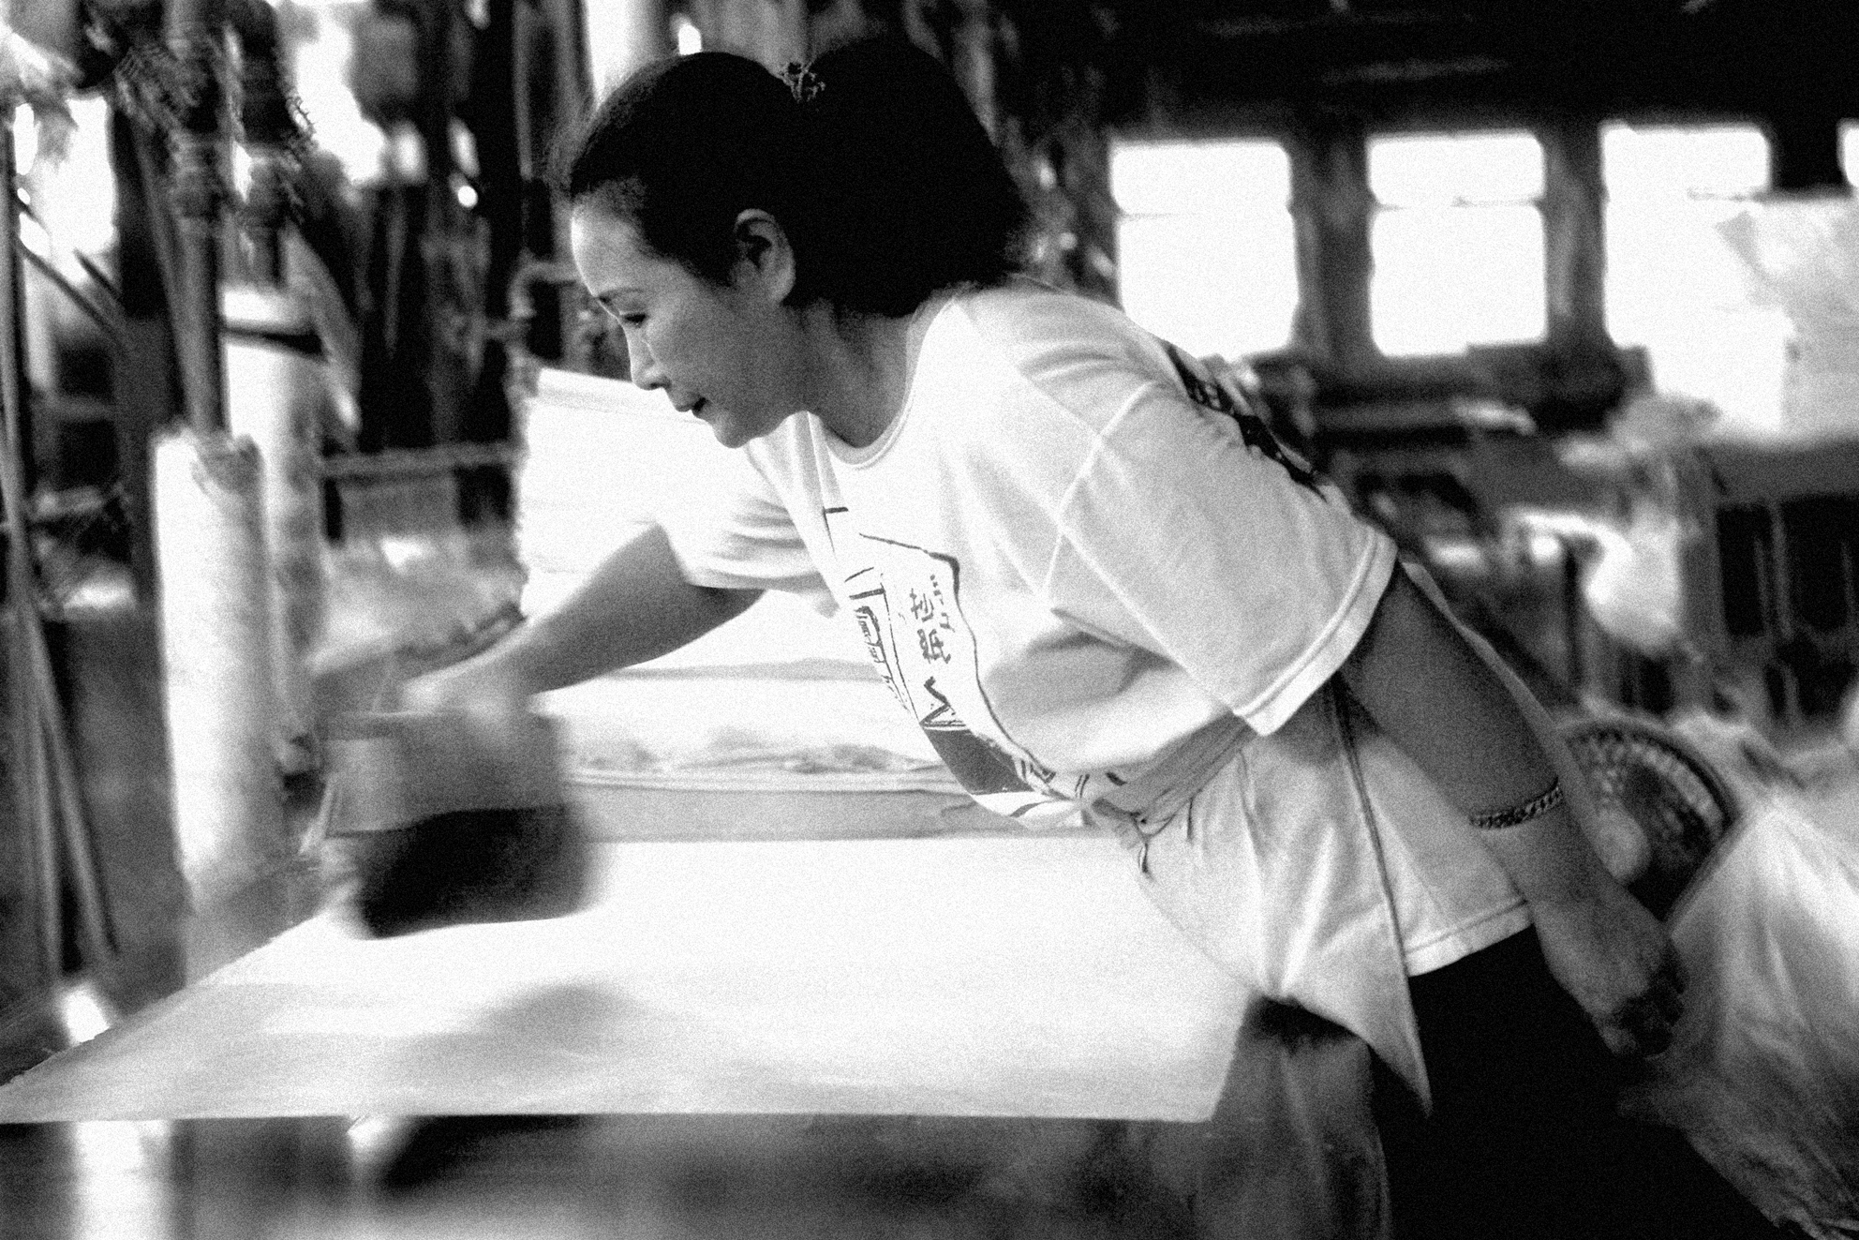
烘紙台用蒸氣９０至１００度高溫由師傅以刷子把紙放在烘台上間接烘乾、刷平。
手抄紙的奧妙在於紙一張張
重疊加壓後它不會連結在一起。烘紙師傅手拿長木棍，木棍放在線旁找出最上層一條線拉開線，紙張抬起附在木棍上一張張很順利的被拉出在烘台上烘乾。師傅刷的力道不能太大力，紙會破；太小力，紙會有皺紋折線，就不行。手工紙是辛苦的行業，也是技術性的工作，在於今天的參觀了解到紙張得來不易，今後我們要更能珍惜用紙、愛惜紙張，做一個好地球人。

Drying the Paper: The paper is moved to the drying area where single sheets are lifted off the stack and placed onto a steaming table. The paper is smoothed onto the surface of the table with a brush, and steamed to dryness. One dried, the paper is stacked ints of hundreds.

